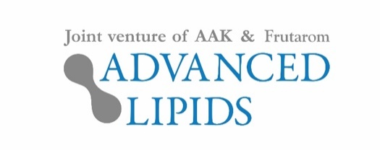

29th November 2019
PRESS RELEASE
Advanced Lipids to launch additions to its INFAT® range at Food Ingredients Europe
Advanced Lipids is launching two new additions to its INFAT® range of high-quality infant formula ingredients.
A new premium offering, INFAT® PRO, offers higher levels of sn-2 palmitate, while INFAT® MF is a special blend containing milk fat. Both new products will be unveiled at Food Ingredients Europe (3rd to 5th December in Paris).
Breastfed babies receive many of their nutritional needs from palmitic acid, the most common saturated fatty acid in humans. 70–80% of the palmitic acid in human milk is attached to the glycerol backbone in the sn-2 position, which facilitates calcium and fat absorption. However, in many oils used in formula, sn-2 concentration is as low as 8–10%.

INFAT® – Advanced Lipids’ original fat ingredient – already contains around 40–45% sn-2 palmitate, enabling formulas to more closely provide many of the benefits of breast milk. Research has shown that babies fed with formula containing INFAT® cry less and sleep more.¹

Other benefits include greater comfort, supporting bone strength and supporting healthy gut bacteria.^{2,3,4} The new premium product, INFAT® PRO, offers even higher levels of sn-2 palmitate – as much as 60% – allowing better absorption of calcium and fat.

Dr Marcus Gliwitzki, CEO at Advanced Lipids, said: “INFAT® PRO allows formula manufacturers to get even closer to the benefits of breast milk. It offers all the advantages of our original formulation but with even more sn-2 palmitate. This means fat, calcium and other essential nutrients can be better absorbed, supporting infant health and development.”

The other new product on show at Food Ingredients Europe (FIE) will be INFAT® MF, a special blend made with milk fat. Adding lipid components from milk to formula offers natural taste, and together with high sn-2, the product is designed to offer “the best of both worlds”.

In addition to INFAT®, INFAT® PRO, and INFAT® MF, Advanced Lipids offers INFAT® Plus, which is designed to be closer to the structure of the breast milk of women from China.

Ronald van der Knaap, Chairman of Advanced Lipids, said: “The ‘one-size-fits-all’ approach no longer works in formula markets, where it’s increasingly important for manufacturers to offer consumers a choice. We’ve worked hard to develop these innovative new additions to our range, and we’re delighted to have the chance to showcase them at FIE.”

All the products will be showcased at Booth #6Q51 of Food Ingredients Europe (3rd to 5th December in Paris).

- Bar Yoseph et al 2017
- Bar-Yoseph et al 2016,
- Litmanovitz et al 2013,
- Yaron et al, 2013
For more information about this press release, contact:

Steve Harman, Ingredient Communications
Email: steve@ingredientcommunications.com
Tel: +44 1293 763007 +44 7538 118079

About Advanced Lipids
Advanced Lipids is a joint venture between Frutarom, a global leader in the fields of taste and health, and AAK, a global provider of value-adding vegetable oils and fats to the infant formula industry and many other industries. Combining Frutarom’s clinical and chemical expertise in lipid technologies with AAK’s international strength in food safety, production and logistics, Advanced Lipids offers a unique package of clinical research, development, flexible blending, quality and logistics.
Find out more at www.advancedlipids.com

